**.netcore**

# //Interpreted languages vs compiled languges

Js java / .Net Core

# //history

< 1994 Qbasic (Ex: cmd you cant use the mouser to click )

1994 --> 1999: 1,000,000 applications were written with VB6

(+) --> very easy to learn and to develop

(-) -->registration hell : the application we tighly coupled to the OS on which you develop ed the application.

VB: visual basic

In this years the problem is: you cant give the application than you created in your laptop for any one ‘cause VB6 depends on the windows wish you use it.

DLL: Dynamic Linked Library {many file.dll form the windows }

Registration Hell is transport the DLL of computer used for develop the application to the client computer

For that in 2000 Microsoft create .net framework

This frame work is now on all computer C: /windows / Microsoft.NET /Framework64

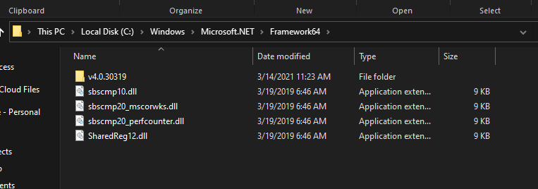

**NB: any time you do update for windows you update the .NET frame work (in windows 7>)**

**.NET Frame work is a compilation of dll files**

So The result than Microsoft finded is to get the .NETframe work on the internet and the client download the same version of the programmer who develop her application

🡪in 2015 : bench market create the same web API with nodejs , java and .NETframe work

Nodejs , java , .NET framework

110,000 r/s 80,000 r/s 1,400 r/s

2016: .NET core

120,000 , 85,000 r/s 140,000 r/s

2019:

140,000 , 90,000 , 1,040,000

Microsoft create new languages:

C,c++ -->c#

Java -->j# --> the result is .dll

VB6 -->VB.net

Cobol -->cobol.net

# //.Net frame work

.NET Framework was a solution for registration hell problem, has on its turn 2 huge limitation:

1. Slow compared with nodejs and java.
2. It runs only om windows

.NET core: cross Systems (tosay’s version is 3.1)

.NET core: 5.0

.NET core is free to download and Microsoft create a way like nodejs :

1. To running js.file you should install nodejs cli | in .net core you should install .NET Core runtime (when you install .NET Core SDK you install in the same time the runtime)
2. Node –version | dotnet –version

SDK: software developpement kit: it’s a collection of tools that allow you to create .dll

Dotnet –version (version of dotnet)

Dotnet –list-sdks (version of sdk)

Dotnet –list-runtimes (version of runtimes)

Dotnet new console

# //advantage

Using .NET Core you can create any kind of app you want

The biggest advantage of running javascript via nodejs is the simple learning curve

.Net needs more time to be learned

Nodejs has two big limitation:

1. The src code is in plain text
2. At build time ()when you develop your code ) you might not notice som syntax error

.net world

1. You don’t provide to the end user the source code but .dll file (so your intellectual property is secured)
2. In case there is a syntax error in your code, you (as a developer)will notice it before the client
3. thread

# //.Net Core

If you go to the my computer you cant find the .Net Core inside :C but it’s inside program file because it’s not only inside windows

# //download

There are run .net core time: use it to only run the dll file which the developer send to you

and .net core: use it to develop and to run

# //.Net Core project

Dotnet new console

Dotnet new in typing this code you can see all kind of project you can do it by .NET Core as angular..

Dotenet build for ransform to .dll file (create a bin folder has the dll files)

Dotnet run compile the cs file to file.dll (you can use it if you on the file but if not you type dotnet file.cs)

Nuget.org it’s a website like npmjs.org

Not all the .dll you can run it ‘cause  (executed)

**NB: any dll you wanted to use it, you don’t need to imported ‘cause it runs by the run time downloaded**

**If you have the version runtime 5.0 you can run .file typed by developer used 3.1 but the inverse is not correct; ‘cause version 5.0 has .dll files not on the 3.2**

**The only dlls you can use it without reference it is who’s in the .NET Core**

# //dll

Dynamic link library

# //reference dll library

Dotnet add reference ..\folder\file.csproj

I’m in the project and I wanna reference a library than other send to me. When you referenced you can see it in the file.csproj

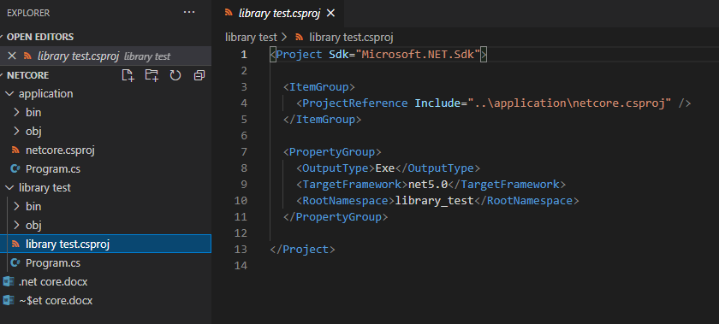

**Remarque when I try to reference the libraryTest file (version 5.0) to the application fie (3.1) the operation was failed but the inverse is true**

# //file.csproj

It’s the same of file.json

Give all reference you needed to your project / the type of the project

# //compilation

All c# file is Compile to one dll file then run it, and we can decompile it;

# //dotnet build

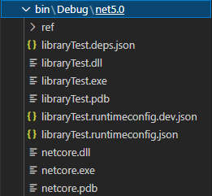

# //triks

Static: when you create static method without create an object for class you can call the property without “this” as:

Public class person{

1.Public void test();

}

Person x = new person();

x.name = “ahmad”

2.public static void test();

person.test();

but in this case you can’t access property by this

# //namespace

To avoid the dlls repetition name between your created library and dll typing by microsoft you use the namespace:

🡪Library.cs:

Namespace ahmad.sarraj.com{

Public class person{

Public static void test();

}}

🡪app.cs

Using ahmad.sarraj.com;(typing it in the top of the page)

//Use the class and the function

**Remarque: any class you used you can go to the definition and read the contain**

# //syntax

* **WriteLine() & Write();**

These are methods, the difference is that WriteLine type something with a new line but Write type without new line.

* **Variables**

Type variableName = value;

Int radius = 4;

* **Data type**

Integer , double , char , string , Boolean;

* **Input**

Console.ReadLine(); // but it is just read the string so if we wanna read an int we should covert it to an int

🡪var a = Convert.ToInt32(Console.ReadLine());

* **write a text in another file**

System.IO.File.WriteAllText(@”string-path” , string);

* String.Format

It’s a way to format the object to string

For example:

String.Format(“{0} we will go to the {1}”,today , university); ---> today we will go to the university

# //class lib

Dotnet new classLib

This class you cant run it because it’s not exutable

1file dll ---> many cs files --->many classes

# //constructor

The constructor is a function which run directly when you run the app without activated by hand

To create a constructor in the c# it should:

1. Create a new object from the class
2. Edit in the new class

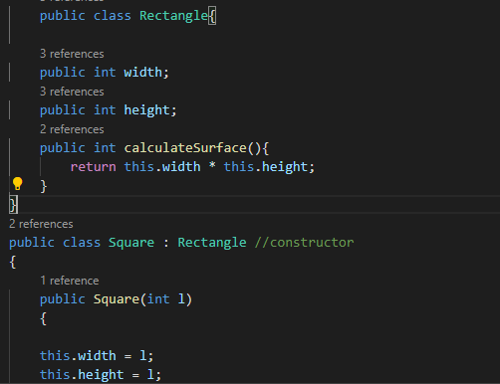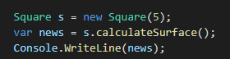

# //over loading

In c# you can create many method with the same name in your class buttttt each method should differ by the number and by the types of its parameter.

For example method write has many over loading

 public static void Write(string? value);

public static void Write(string format, object? arg0);

public static void Write(string format, object? arg0, object? arg1);

public static void Write(string format, object? arg0, object? arg1, object? arg2);

# //visual studio

Solution is a collection of project

If you want to reference any project you can do it in the solution file

# //class and object

You can create your class then create a new object from this class for example:

Public class result{

Public rectangle surface(){

Var s = new rectangle();

s.width = 45;

s.height = 50;

return s;

}

}

Public class rectangle{

Public int width;

Public int height;

}

# //web API

Create a new API project

The power of API on dotnet core is translate the URL

## //IIS express

Is a software install with the installation of the visual studio miniature of IIS for that you don’t need to install IIS on your desktop

## //The controller

create a new controller // < ----  A **controller** determines what response to send back to a user when a user makes a browser request. A **controller** is just a class

In this file there are a clas decorated by

[Route("api/[controller]")]

[ApiController]

This decorator which make this class an controller. This class like another class accepted to has constructor and function

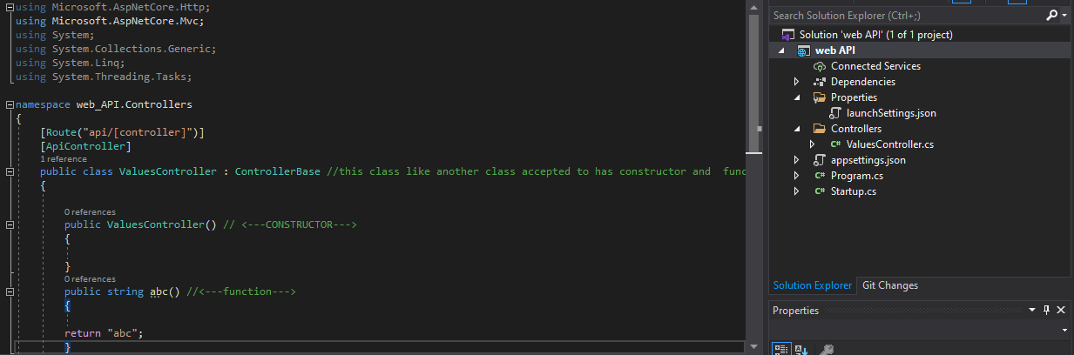

## //launchsettings

Property > launchsettings

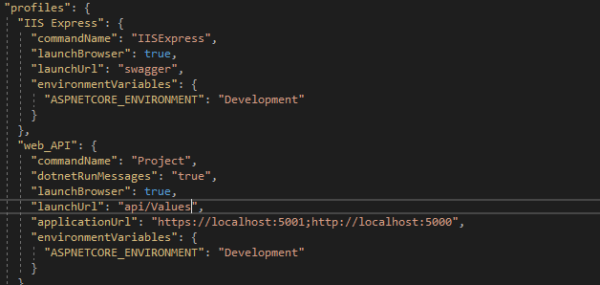

In the launchUrl there are the situation of the API

## //inheritance

**Inheritance** is the procedure in which one class **inherits** the attributes and methods of another class

For example: if we have two classes “chef” and “Italian chef”

We can use the prorerties and the methode of the “chef” class in the other class

Public class chef{

Public makeChiken(){}

} => chef can makechiken

Public class ItalianChef : chef {

Public makePizza()

} => ItalianChef can makeChiken and makePizza;

## The object

The object is an instance from the class

## //Ambiguous

When we have two or more function we should decorated it and call it in the URL to avoid the ambiguous

**Decorated by :** [Route(“A”)]

## //list<class>

Represents a strongly typed list of objects that can be accessed by index. Provides methods to search, sort, and manipulate lists

## //post

[httpPost]

Public void createStudent(){

String[] Files = System.IO.Directory.GetFiles(_config[“Data_folder”])

s.id = FilesCOunt() +1;

String str_content = string.Format(“{0},{1}”, s.id , s.name);

String str_filepath = string.Format(@”{0}\{1}.txt” , _config[“Data_Folder”]);

System.IO.File.WriteAllText(str_filepath , str_content);

}

1. Create an array read the content of the path
2. Generate the id
3. Determine the content
4. Determine the path
5. Add the content and the path

## //application

* ICOnfiguration is an interface read for appsettings;

1. Make a property call “IConfiguration ” 🡪 IConfiuration _config
2. Give the constructor a parameter whatever his name for type IConfiguration
3. In the source code make _config = config
4. Go to the appSettings and specify the directory
5. Create class call MainClass
6. Create a method List
7. //create a new object from List<>class
8. // create a string array read the files in the data folder in the appsettings
9. // if the file is not null
10. //foreach is a loop to read in the array :: foreach(var file in MyFiles) == for (int file = 0 ; file = MyFiles.length ; file ++)
11. //create a var to read text in MyFile
12. //if the content is not null
13. //create a new string array to split the content variable
14. /// if the parts array is not null
15. //create a new object from the students class
16. //the content of the id is the part 1 of parts array
17. //the content of the name is the second part of the parts array
18. //add s (the instance of the students class) to the olist (the instance of the list class)

* appSettings:

“DATA_FILES” : “PATH”

* public class student  
  {

public int id (get; set;)

public string name (get; set;)

}

Public List<student> GetAllStudent()

{

List<student> olist = new List<student>();

String[] MyFiles = System.IO.Directory.GetFiles(“DATA_FILES”);

If(MyFiles != null){

Foreach(var file in MyFile){

String str_content = System.IO.ReadAllText(file)

If(! String.IsNullOrEmpty(str_Content))

{

String[] parts = str_content.split(“,”)

If (parts !=0){

Student s = new student();

s.id = Convert.ToInt32(parts[0]);

s.name = parts[1];

}

Olist.Add(s);

}

}

}

Return olist;

}

## //signal R

To make the exercise smarter!! By don’t need to refresh the screen to re-call the API to get result back but to do it by herself

## //http action verb

GET ---> read [httpGet]

POST---> create [httpPost]

PUT--->Update [httpPut]

DELETE ---> delete [httpDelete]

In the highlite is the ASP.Net core attribute

# //Delegate

Delegate is the same of class but A [delegate](https://docs.microsoft.com/en-us/dotnet/csharp/language-reference/builtin-types/reference-types) is a type that represents references to methods with a particular parameter list and return type. When you instantiate a delegate, you can associate its instance with any method with a compatible signature (the method name and the parameter ) and return type. You can invoke (or call) the method through the delegate instance.

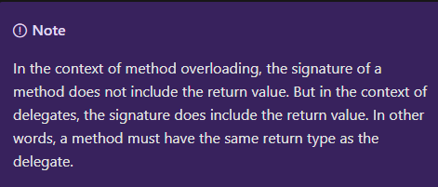Delegates are used to pass methods as arguments to other methods.

--->

Class email {

public string from {get; set;}

public string to {get; set;}

}

Public static void xyz(string c){

Return c;

}

Public delegate void ahmad (string x){}

Email d = new Email(); //you can not give a method = ahmad a = new ahmad(xyz); //in delicate you can give a method

d.from = “” a.Invoke(“hello world!”)

d.to = “”

**analyse: when we create two method and one delicate, next we give the first method in the parameter of the delicate the delicate run that method.**

**Delicate vs class: object of delicate take a method vs object of class take the data type which you identify.**

**Summary: so a delicate is a type that can take only methods and run it,to determine the assigned to certain variable. and the method must have the same return type of delicate.**

# //events

# Reference my dll

# .dll

# Asp.net core , console …

# .dll

Events is just a place in my code to be able to edit in my code after finished and without what is the source code in the dll.

The events is put it in the lib code

namespace SampleApp {

public delegate string MyDel(string str);

class EventProgram {

public event MyDel MyEvent;

public void startEvent{

if(this. MyEvent != null){

this. MyEvent ();

}

}

**To active this events it should do :**

**//go to the app that do ref to my lib + new object of class that contain the event**

**EventProgram p = new EventProgram();**

**p.** MyEvent += (Tab Tab to create the method)

and next you go to the method and type your code

# //background service / worker service

It’s make it after 3.1; and it’s a type of projects in vs

In this project there are two files.cs : worker.cs &

is active by that

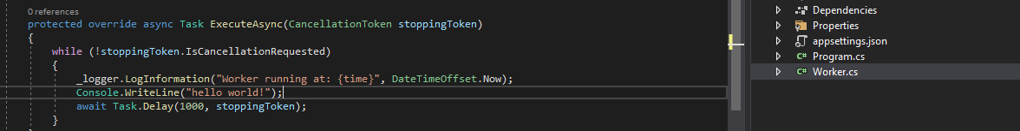

stop

time

Every code typed here

Is run by this



## task

is a way to use multiple thread

Thread 2

Thread 1

task.start();

Child code

Main code

Main code

Main code

Child code

**task.wait() vs don’t use of task (dut):**

when I use don’t use thread the code run in one CPU but if I use task.wait() the code give the same result but by using multiple thread**;**

//if I have 2 codes: main and child;

Main code

Child code

Main code

-->dut: -->task.wait();

Child code

Main code

Main code

Main code

Child code

Main code

## Async & await

To avoid use task and task.wait() every time you decorate the task method with async and use await;

Static void Main..{ public static async Task Metod1(){

Task t = new Method1(); 🡪 await Task.run(() =>..

t.start(); t.wait(); static void Main..{ method1(); method2();

method2();

this code return a task and await every 1000 ms

protected override async Task ExecuteAsync(CancellationToken stoppingToken)

{

while (!stoppingToken.IsCancellationRequested)

{

_logger.LogInformation("Worker running at: {time}", DateTimeOffset.Now);

Console.WriteLine("hello world!");

await Task.Delay(1000, stoppingToken);

}

}

# //thread

To use multy cores in the cpu. To active on parallel;

I create a new method call ThreadProc;

In the main method I enter this syntax:

Thread t1 = new Thread(new ThreadStart(ThreadProc));

t1.Start(); // <--! to active code in the first core

Thread t2 = new Thread(new ThreadStart(fYellow)); // <!-- fYellow is a method which Microsoft make it and than change the color of the console word to the yellow,

T2.Start(); // <!-- to active code in the second core

NB: my CPU has only 3 cores for that if I add a new object t3 that will not be active.

CPU 2.9

0.8

0.8

0.8

0.8

To open the resource monitor:

Task manager > performance > resource monitor

The CPU contain cores; my PC has Ntel(R) Celeron(R) N4000 CPU @ 1.10GHz

It’s contain 2 cores.